Contents
No table of contents entries found.

Automated Java Code Generation
- Existing project from C-SW321 was continued.
- A Maven-compliant project was created at:
Software-Design-&-Development-Project/HospitalMangementSystem_Maven
- Source code from the NetBeans Ant project (HospitalMangementSystem) was copied into Maven src/main/java structure.
- pom.xml was configured to use the main class: hospitalmangementsystem.HospitalMangementSystem
- NetBeans Maven Clean and Build: BUILD SUCCESS
- NetBeans Maven Run: Application starts and displays the HMS menu (UC-02 Register Patient, UC-06 Cancel Appointment)
- DevOps environment incorporates: NetBeans (IDE), Git (version control), Maven (build automation), JIRA (task management).

Identified Cases (2 Singleton, 1 Factory Method, 2 Abstract Factory)
Identified Cases for Creational Design Patterns
Note: Cases will be finalized in task A2 after Andrew proposes B1/B2. Initial candidates are:
Singleton Cases (2)
- NotificationServiceSingleton
  - Problem: Ensure a single, globally accessible notification service across the system.
  - Rationale: Notification is a cross-cutting concern; multiple instances would cause duplicate notifications and resource waste.
- PatientRegistrySingleton
  - Problem: Maintain a single in-memory registry of active patient sessions during runtime.
  - Rationale: Prevents duplicate patient session objects and provides a consistent lookup point.
Factory Method Case (1)
- AppointmentFactory
  - Problem: Different types of appointments (e.g., Consultation, Surgery, FollowUp) need to be created based on appointment type.
  - Rationale: Encapsulates object creation logic and supports future appointment types without modifying client code.
Abstract Factory Cases (2)
- ReportAbstractFactory
  - Problem: Generate family-related reports (PatientReport, BillingReport, AppointmentReport) with consistent formatting.
  - Rationale: Ensures all report objects are compatible and can be swapped for different output formats (e.g., PDF, HTML).
- UIComponentAbstractFactory
  - Problem: Create consistent sets of UI components (Console, Swing, Web) for different deployment targets.
  - Rationale: Guarantees UI consistency within a family and allows easy switching between UI styles.

UML Diagrams
- Singleton Case #1
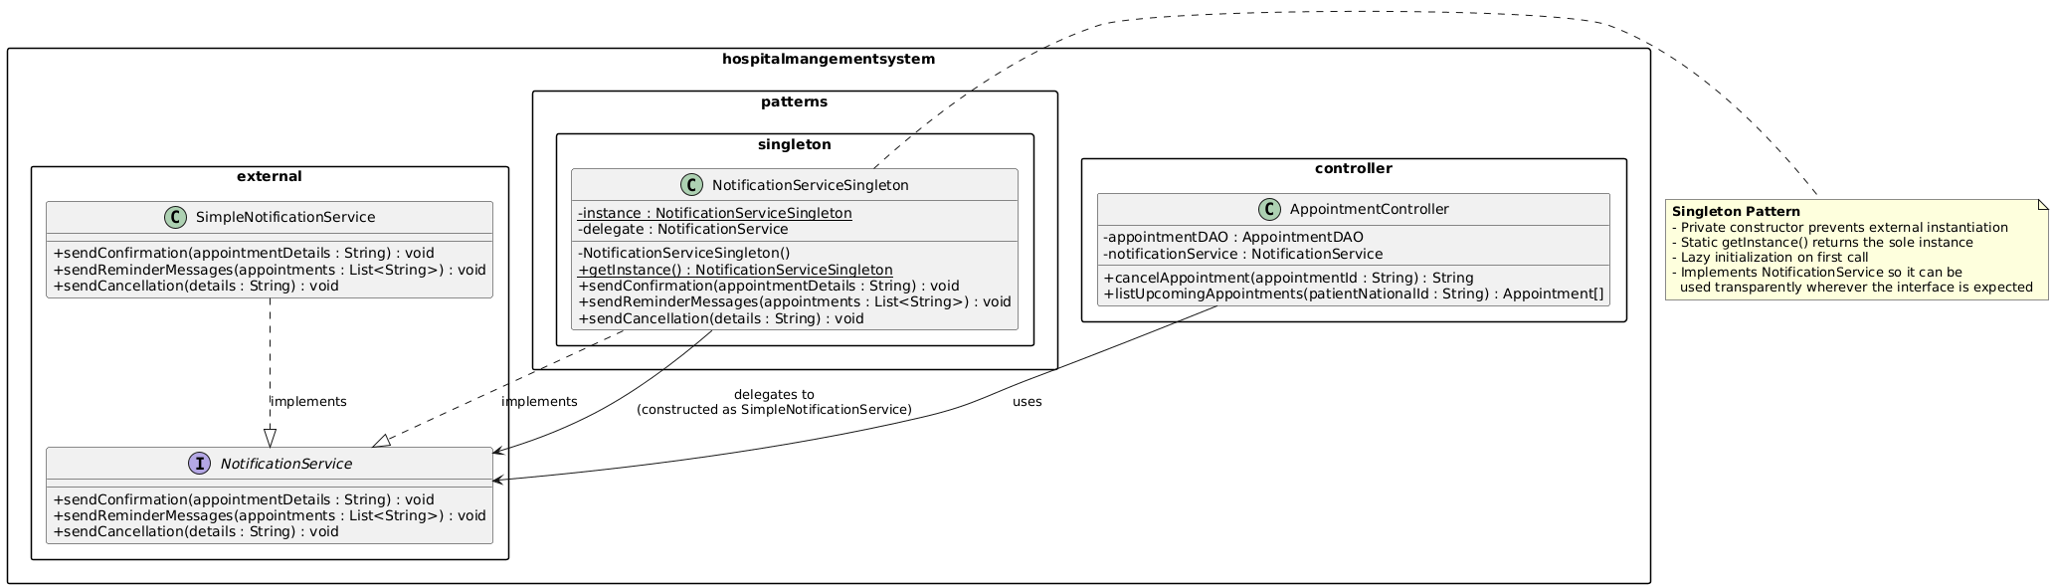
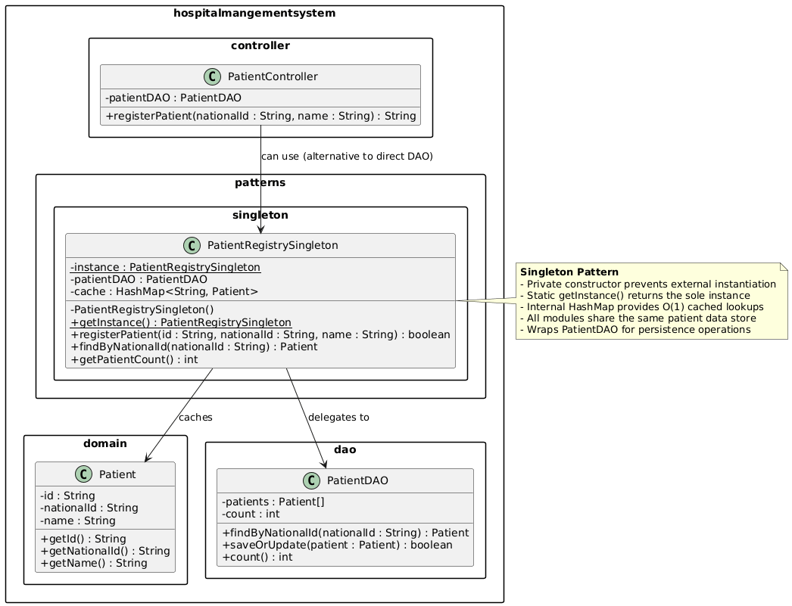
- Singleton Case #2:

- Factory Method Case:

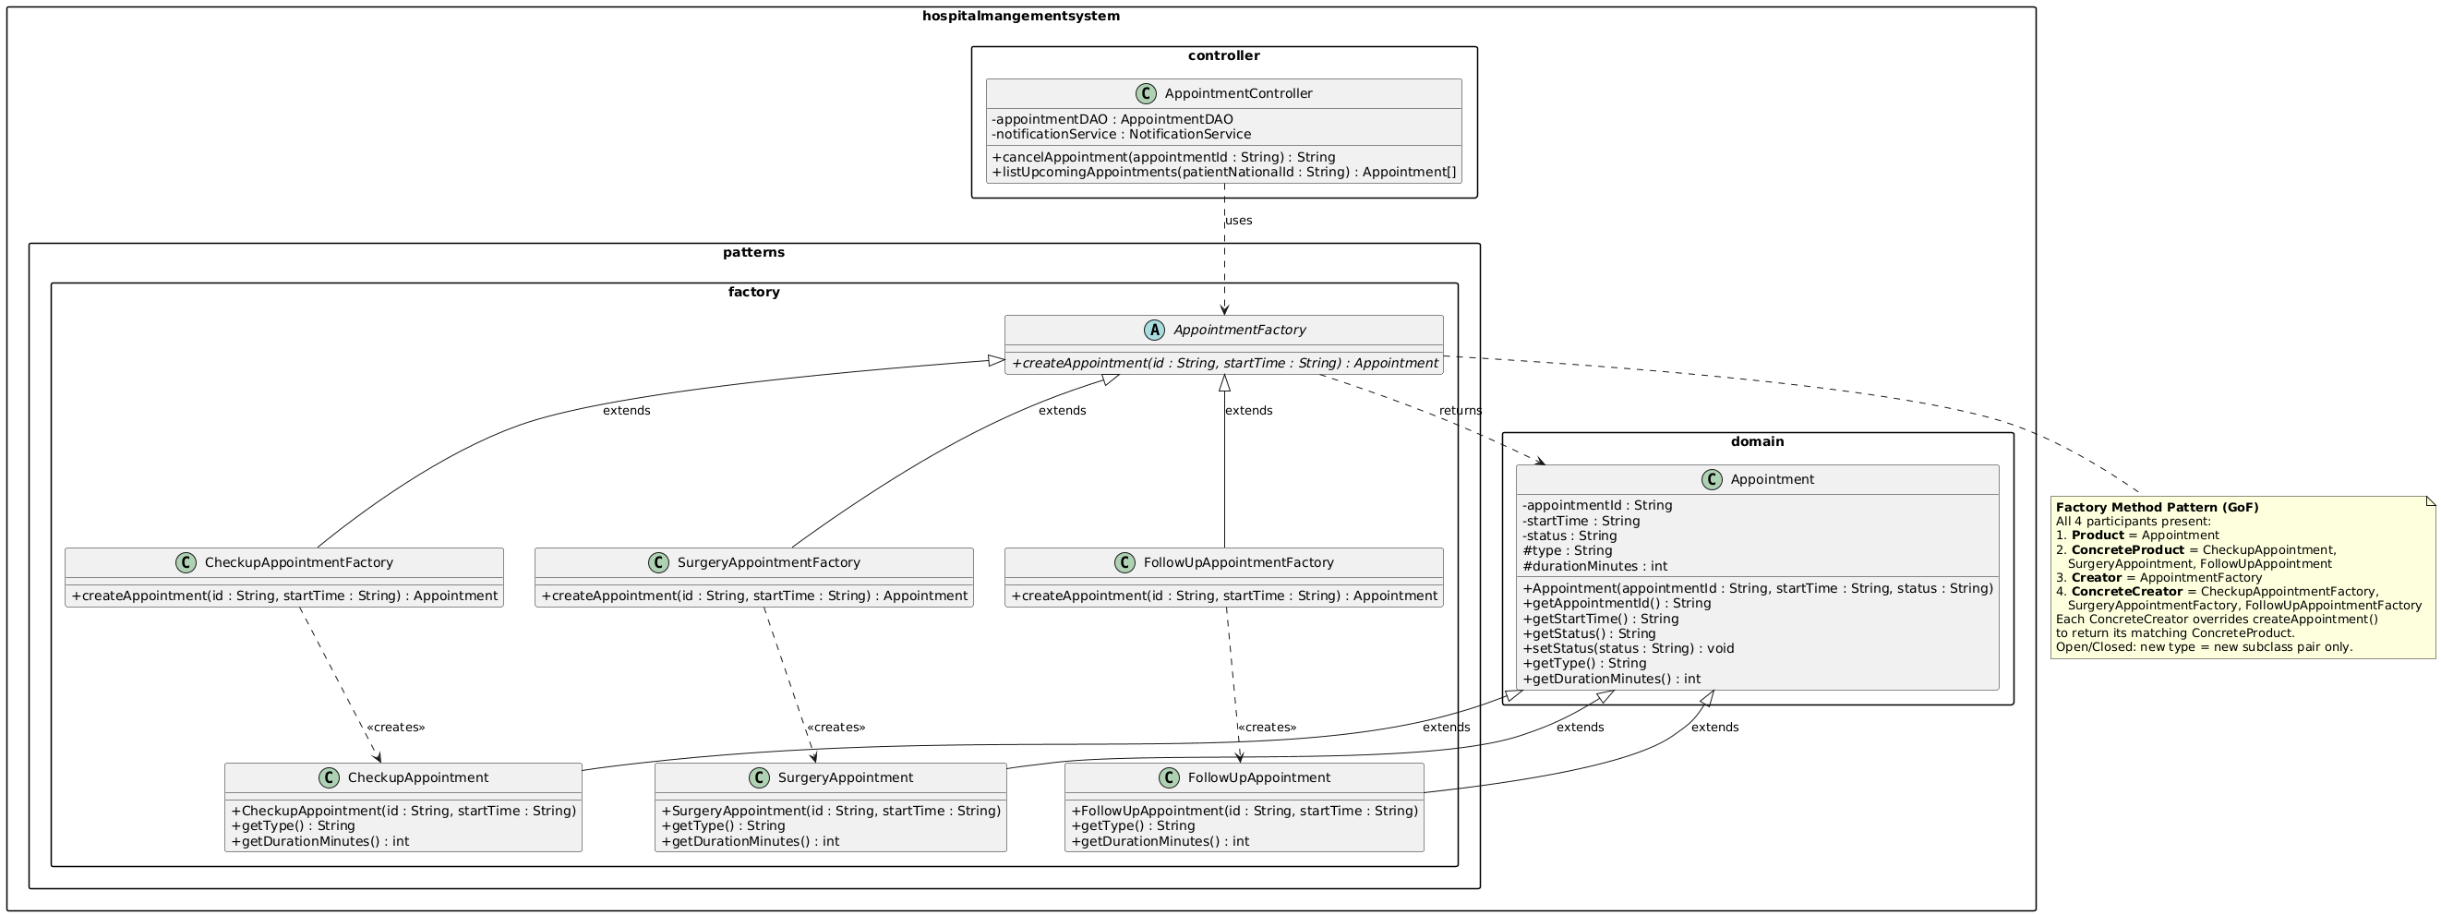

- Abstract Factory Case #1: [UML diagram placeholder]

Justification per Case. Justification for Each Pattern
Case 1 — Singleton: NotificationServiceSingleton

Problem
The system sends appointment confirmations, cancellations, and reminder notifications using a SimpleNotificationService.
Originally, this service was instantiated in the main() class and passed to controllers through constructor parameters.
This design creates several issues:
- Multiple instances of the notification service may be created.
- Configuration must be repeated for each instance.
- Controllers require constructor wiring, increasing coupling and complexity.
As the system grows, maintaining consistent notification behavior becomes difficult.
Pattern Application
The Singleton pattern was applied to ensure that the notification service has only one instance in the entire application.
The NotificationServiceSingleton class:
- Uses a private constructor to prevent external instantiation.
- Maintains a static instance field.
- Provides a static getInstance() method that returns the shared instance.
- Delegates notification operations to a SimpleNotificationService implementation.
Controllers access the service through NotificationServiceSingleton.getInstance().
Result
- Guarantees a single notification service instance.
- Ensures consistent configuration across all modules.
- Simplifies dependency management.
- Prevents duplicate or inconsistent notifications.

Case 2 — Singleton: PatientRegistrySingleton
Problem
Patient data is stored and accessed through PatientDAO.
However, multiple components may need to retrieve or update patient records during runtime.
Without centralized management:
- Each module may perform repeated DAO lookups.
- Duplicate patient objects may appear in memory.
- Lookup performance may degrade as the system grows.
Pattern Application
The Singleton pattern was applied by introducing PatientRegistrySingleton, which acts as a centralized patient registry.
The class:
- Maintains a single shared instance of the registry.
- Delegates persistence operations to PatientDAO.
- Uses a HashMap cache to store Patient objects indexed by national ID.
This allows all modules to access the same patient registry instance.
Result
- Ensures a single shared patient registry.
- Provides fast O(1) patient lookups through caching.
- Maintains consistent patient data access across the system.
- Reduces repeated DAO calls.

Case 3 — Factory Method: AppointmentFactory
Problem
The system supports multiple appointment types such as:
- Checkup appointments
- Surgery appointments
- Follow-up appointments
Creating these objects directly inside controllers would require conditional logic such as if or switch statements. As more appointment types are added, the controller becomes tightly coupled to concrete classes and difficult to maintain.
Pattern Application
The Factory Method pattern was implemented to encapsulate the creation of appointment objects.
The design includes:
- Product: Appointment
- ConcreteProducts: CheckupAppointment, SurgeryAppointment, FollowUpAppointment
- Creator: AppointmentFactory
- ConcreteCreators:
  - CheckupAppointmentFactory
  - SurgeryAppointmentFactory
  - FollowUpAppointmentFactory
Each concrete factory overrides createAppointment() to instantiate its corresponding appointment type.
The AppointmentController interacts only with the abstract AppointmentFactory and Appointment classes.
Result
- Removes object creation logic from controllers.
- Allows new appointment types to be added without modifying existing code.
- Improves maintainability and scalability.
- Supports the Open/Closed Principle.

